CMIT 388 CMIT 388 Model Red Hat Linux System Administration I
Project 1 Work Product

Name: Diamond Wellons
Section: CMIT 388 7381

Instructions
Type the exact command used to complete each step after the corresponding number below and the paste the screenshot as outlined in the project instructions.

Part One

- Sudo groupadd -g 6000 lnxgrp

- Sudo useradd -u 5000 -g 6000 userp1

3. sudo passwd userp1
chage -M 4 userp1
chage -M 30 userp1
chage -W 10 userp1
chage -E 2025-12-20

4.visudo
Userp1 ALL=(ALL) NOPASSWD: ALL

5a. sudo users

5b. sudo groups

Screenshot 1:

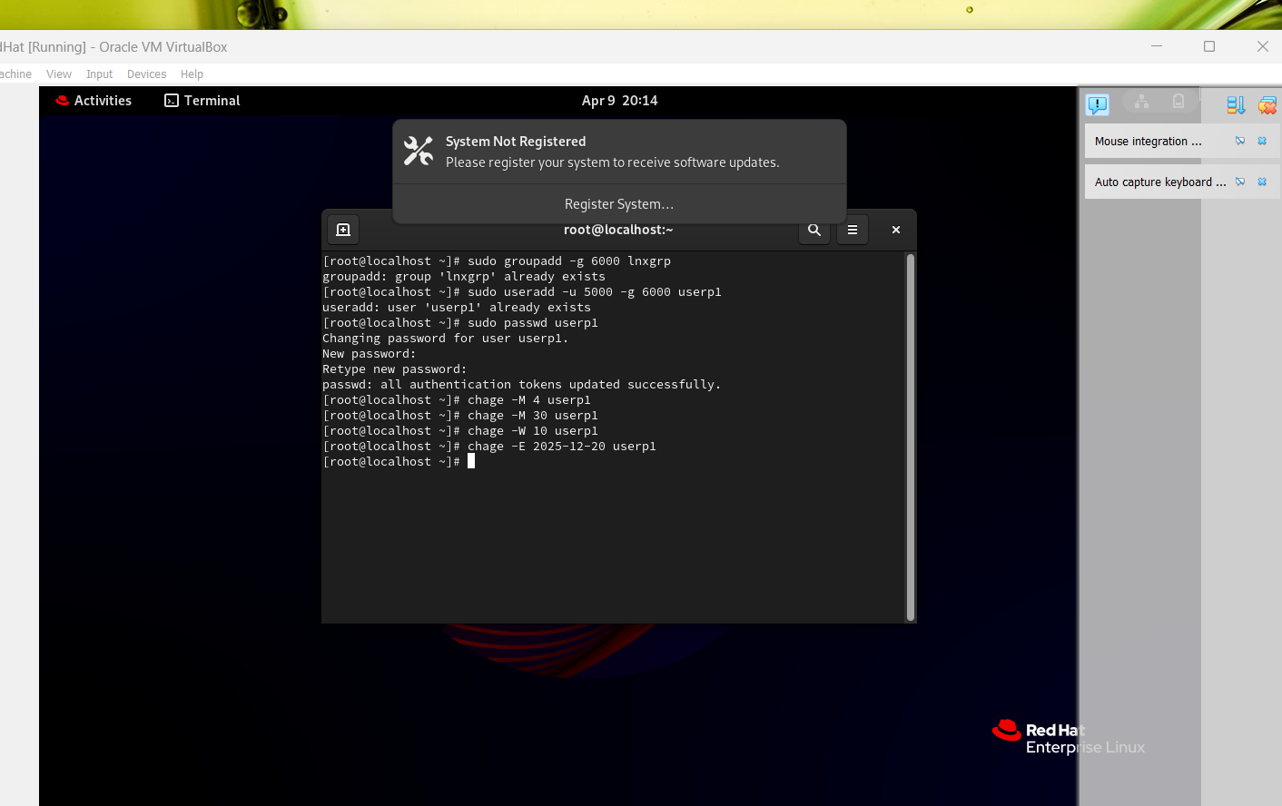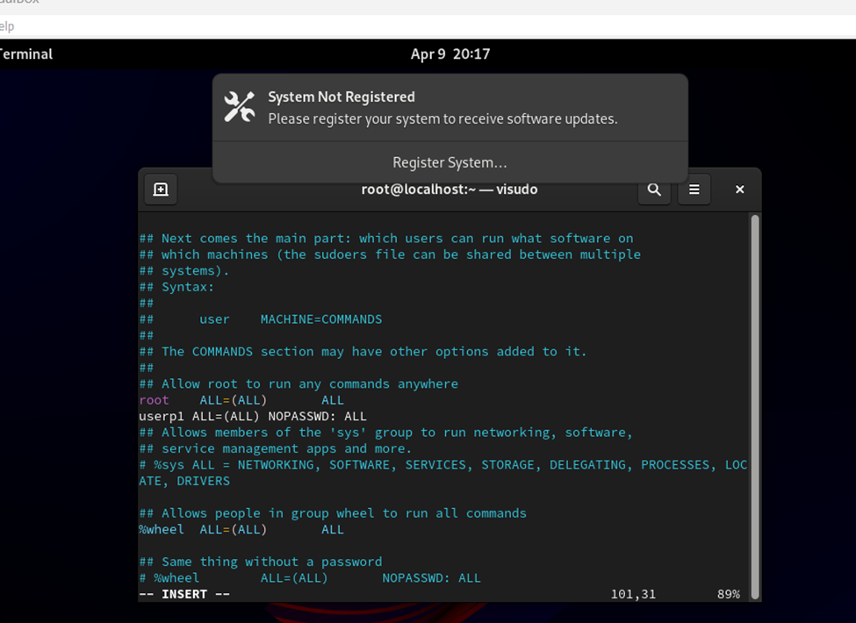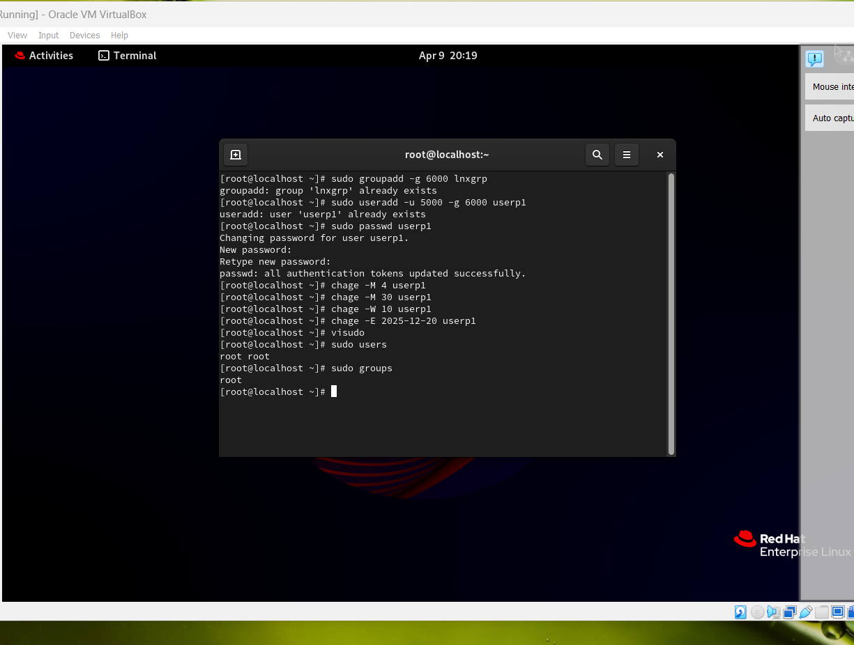

Part Two

- Touch file1
Mkdir directory1

- Sudo useradd -u 5001 -g 6000 userp2
Sudo chown userp2:lnxgrp file1

- ls – laht /tmp
- Sudo groupadd lnxgroup2 -g 6001
Sudo chown -R userp2:lnxgroup2 directory1
- ls -laht

Screenshot 2: 